**Money Test**

**Question 1**

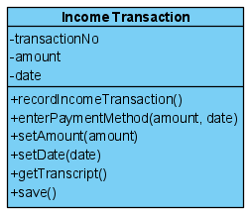 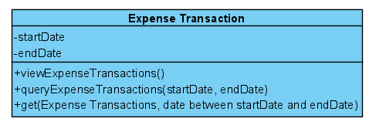

**Question 2**

|  |  |  |  |
| --- | --- | --- | --- |
| Use Case Name | Record Income Transaction | | |
| Triggering Event | Customer pays for work done | | |
| Brief Description | Allows the Owner to record an income transaction | | |
| Actors | Owner | | |
| Related Use Cases |  | | |
| Preconditions | Owner has opened the Main Menu. | | |
| Post Conditions | Income transaction is recorded | | |
| Flow of activities | Actor | | System |
|  | 1. | Requests to record an income transaction | Displays a list of payment methods and prompts for selection. Prompts for amount of transaction and transaction date (defaults to the system date) |
|  | 2. | Selects a payment method, enters date and amount | Displays the transaction and prompts for confirmation |
|  | 3 | Chooses to confirm | Saves the transaction. |
| Exception Conditions | * Owner chooses to cancel recording income transaction. | | |

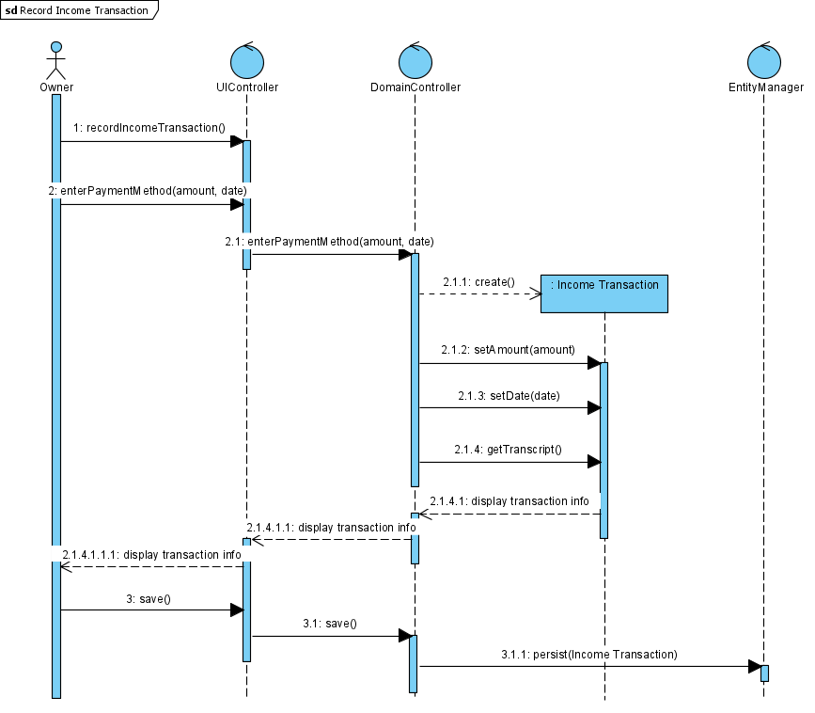

|  |  |  |  |
| --- | --- | --- | --- |
| Use Case Name | Query Expense transactions | | |
| Triggering Event | Owner requires a list of expenses | | |
| Brief Description | Allows the Owner to review expense transactions | | |
| Actors | Owner | | |
| Related Use Cases |  | | |
| Preconditions | Owner has opened the Main Menu. | | |
| Post Conditions | Expense transactions retrieved | | |
| Flow of activities | Actor | | System |
|  | 1. | Requests to query expense transactions | Prompts for start and end date |
|  | 2. | Enters a start and end date | Retrieves expense transactions that meet the date requirements. Displays the list |
| Exception Conditions | * Owner chooses to cancel querying expense transactions. | | |

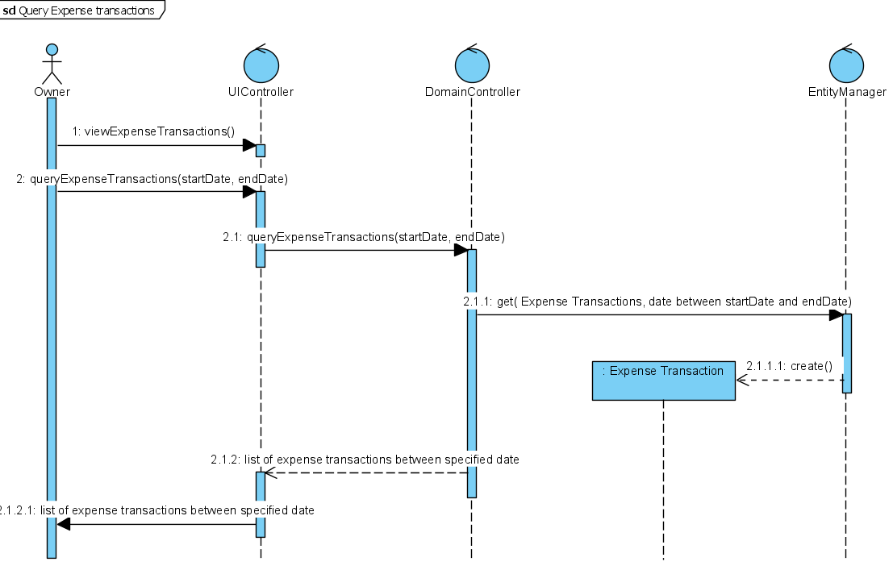

**Question 3**

An attribute for the customer would be added to the Income Transaction class. This way, respecting our case scenario, every time we want to record an income transaction, we display the customer info as well as the transactionNo, amount, and date. The enterPaymentMethod function should get modified to receive another parameter called 'customer'. In addition, we declare a new function called setCustomer() and we call it when we want to retrieve the related transaction info from the class.

**Question 4**

I would add an attribute called 'points' to the Expense Transaction class to help Jenny have a better observation on when she uses points to buy products from her favorite suppliers. It is not necessary, but we can modify our sequence diagram to retrieve points from the Expense Transaction class as well when want to query an expense transaction.

**Question 5**

Some goods and services are exempt from HST, that means the business owner pays no tax to claim those products or services. HST exempt is different than HST zero-rated goods; HST zero-rated goods and services are considered taxable items, but the tax rate for them is 0. Buying HST exempt products is a great deal for Jenny's company as she would save more money and could buy more items; but the thing that we need to note regarding the HST exempt is that it also prevents the business owner to claim ITC (Input Tax Credits).

**Question 6**

Receiving cash money from the clients can save up some money for Jenny and her company; Jenny could save up to 2.5% on each cash transaction. Paying in cash is desirable for clients as they won't pay taxes on the goods they buy from Jenny, and it is somehow good for Jenny, too. On the other hand, receiving cash payments has its own problems. There would be no proper trail on the transaction anymore. When buying with credit card or cheque, a record is saved on the system and it makes the management of the incomes and expenses easier for Jenny and her company.

**Question 7**

My team and I have decided to pick Agile Project Management Methodology. Agile methodology is an advanced methodology designed for projects that need to change rapidly and for the projects that their solutions and requirements evolve as time passes, like Jenny's business; there are a lot of improvements and enhancements that we should apply to her project, and that needs agile methodology. With adaptive planning, we have lots of flexibilities to adapt to the needs of future clients. The thing about waterfall methodology that prevents us from choosing it is that somehow the entire project should be planned upfront without the freedom to change some of the requirements. Using agile methodology for *Auto Supplies Ltd’s* project, we go through a continuous iteration of development and we test it all the time until the end of the project.